**Thurston County Water Resources**

**Technical Memorandum #6**

Prepared by

Nathaniel Kale

Water Resources Specialist II

Thurston County, Washington

December 20, 2016

Formatting and Evaluating Precipitation Data  
1988-2000

# Goal

To transform Thurston County precipitation data from 1988-2000 into a usable format and file type, for future analysis and for import into the new GData database. Additionally, perform quality assurance/quality control on historic data.

# Results

There were 13 precipitation monitoring sites active during part or all of the 1988-2000 timespan; 8 of those stations are still in operation as of December 2016.

Table 1: List of Precipitation Monitoring Sites with Data Prior To 2000

|  |  |  |  |  |
| --- | --- | --- | --- | --- |
| **Site Code** | **New Site Code** | **Site Name** | **Start Date** | **End Date** |
| PBL1 | 45u | Littlerock | 1988-03-01 |  |
| PBL2 |  | Capitol Forest Tacoma Trail Cruisers | 1994-09-23 | 2000-01-08 |
| PDE1 |  | Yelm Highway Pump Station | 1993-01-01 | 1996-04-01 |
| PDE2 | 13u | Lake Lawrence | 1992-01-01 |  |
| PEA1 | 10u | Meridian Rd | 1992-02-18 |  |
| PEB1 | 27u | Boston Harbor | 1997-09-12 |  |
| PGC1 | 32u | Kaiser Rd | 1990-06-22 | 2013-01-29 |
| PPE1 | 23u | Percival Creek, Bldg 4 | 1988-03-01 |  |
| PSC1 | 55u | Tenino | 1994-10-01 |  |
| PSL1 | 69u | Summit Lake | 1993-11-01 |  |
| PWD1 |  | 12th Ave - Woodard Creek | 1988-03-01 | 2008-08-06 |
| PWL1 |  | Woodland Creek - TC Fairgrounds | 1988-03-01 | 2008-12-31 |
| PWL3 | 18w | WARC TC | 1993-10-27 |  |

Figure 1: Map of Precipitation Monitoring Sites with Data Prior To 2000

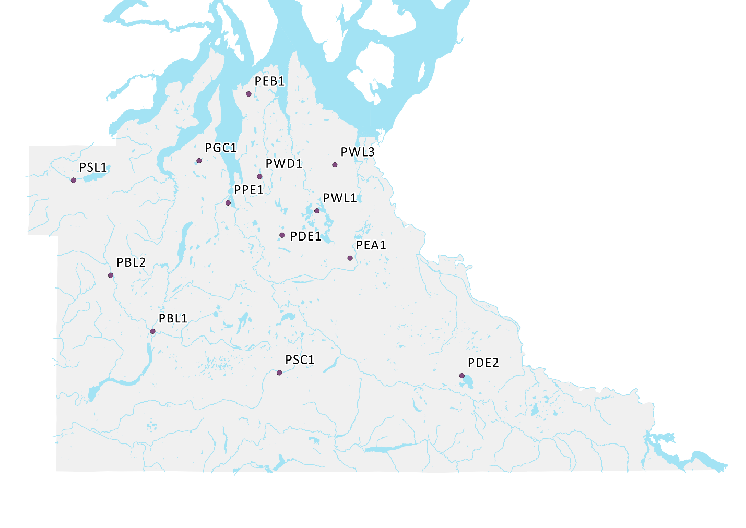

The data collected from each of these sites was over varying spans of time and of varying quality. One sites (PEB1) should be discarded from further study. An additional three sites (PDE1, PDE2 and PWL3) should be carefully analyzed before using in additional research.

Figure 2: Precipitation Station Data Collection Timespan and Quality

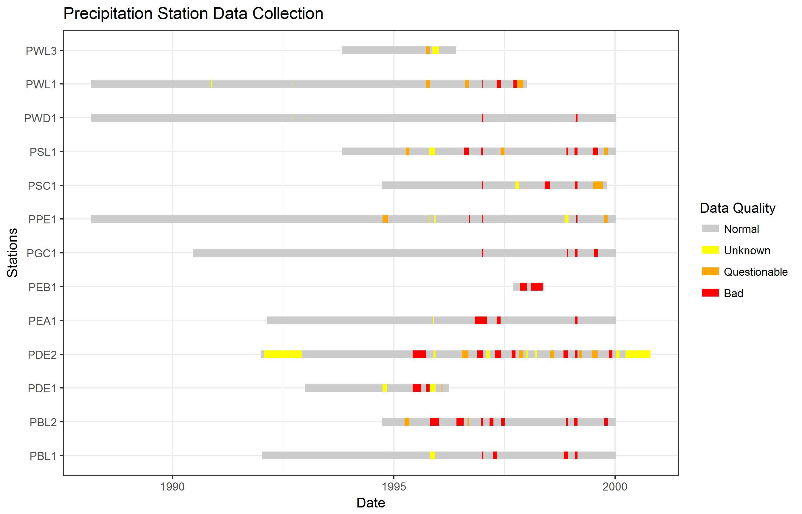

# Methods

## Software

This analysis was conducted in Excel 2013; R 3.3.1 (RStudio 1.0.44, plus packages broom, cowplot, dplyr, ggplot2, readr, tools, and reshape2); QGIS 2.14; and Notepad++ 7.1.

## Data

The primary dataset for this analysis was a set of *.HSP files corresponding to each of the 13 stations listed in Table 1. Those files were generated by ANNIE (part of the Hydrologic Simulation Program: FORTRAN, or HSPF, software suite) sometime between 2000 and 2005. The files contained data in HSPF input format: year, month, day, card number, and 12 columns of 15-minute increment precipitation data. They also contained notes, and occasionally there were errors in the year column.

A second dataset was the location of each of the stations. While not directly integrated into the R scripts that make up the formal analysis, knowing where the stations are in the county was beneficial when deciding how to interpret each station’s correlation with the NOAA gage at the Olympia airport.

## Analysis

This analysis was conducted in six steps:

1. **Clean** the data. This step included removing bad characters and correcting inaccurate date spans in the .HSP files. Despite being step 1, data cleaning was conducted iteratively; as new errors were uncovered, they were addressed, and the analysis was re-run from the beginning.
2. **Reformat** the data. The .HSP files were converted to “long” format .csv files, with a standard date column.
3. **Fill** the data. This step was necessary because the .HSP files leave gaps rather than record precipitation values of 0.
4. **Annotate** the data with quality flags. Much like data cleaning, this was conducted iteratively.
5. **Group** the data from 15 minute into daily.
6. **Compare** the data to the best local long-term precipitation data set – the NOAA station at the Olympia airport.

### Step 1: Cleaning

The goal of this analysis was to make minimal changes to the original .HSP files. Unfortunately some changes were necessary in certain cases to parse the files accurately into R. The three changes were:

1. Some files had been opened and then saved in Microsoft Excel, which converted the normally fixed width format to tab-delimited. Those files were reformatted back to fixed width format without changing the underlying data.
2. Some files had unexpected characters (non-ASCII characters at the beginnings of rows) that disrupted parsing; those characters were deleted.
3. In some files, in some years, ANNIE failed to correctly process the change from one year to the next for up to a month, labelling e.g. 1996-01-01 as 1995-01-01.

The changes made for bullet c) were:

* PBL1.HSP: Fixed lines 2413 through 2449 by changing 95 to 96.
* PBL1.HSP: Fixed lines 4601 through 4719 by changing 00 to 99.
* PDE2.HSP: Fixed lines 2492 through 2591 by changing 98 to 99.
* PEA1.HSP: Fixed lines 2124 through 2157 by changing 95 to 96.
* PSC1.HSP: Fixed lines 940 through 976 by changing 95 to 96.
* PSL1.HSP: Fixed lines 1450 through 1488 by changing 95 to 96.
* PWL3.HSP: Fixed lines 1256 through 1284 by changing 95 to 96.

### Steps 2 and 3: Reformatting and Filling

The .HSP files were all created in a “wide” format designed specifically to work with HSPF. The format has 16 fixed-width columns, with the first four columns being the year, month, day, and “card number”. The twelve columns following the card number are each 15-minute increment precipitation columns, with the capacity to store values from 0.00 to 99.99.

Each day is divided into 8 “cards” (because 8 * 12 = 96, which is the number of 15-minute increments in most days). Each card for each day is uniquely numbered. If any fifteen minute increment in a card records rainfall, the row for that card is written to the .HSP file; otherwise, nothing is written.

For example, an .HSP file might have the following rows:

92 1145 0.01 0.00 0.00 0.01 0.00 0.02 0.00 0.00 0.00 0.00 0.00 0.00

92 1151 0.00 0.00 0.00 0.00 0.00 0.00 0.01 0.01 0.00 0.00 0.00 0.00

92 1153 0.00 0.00 0.00 0.00 0.00 0.00 0.00 0.00 0.02 0.02 0.01 0.01

These rows are for January 14th and 15th, 1992. They show that there was rainfall during card 5 of the 14th (12:00 to 14:59), and during cards 1 and 3 of the 15th. There was 0.01” of rainfall from 1/14/1992 12:00 to 12:14, 0.00” from 12:15 to 12:30, etc. They also indicate that there was no rainfall between 15:00 and midnight on the 14th, because there is no data recorded for cards 6, 7, or 8.

These data were reformatted to “long” format, with one precipitation value and one date/time value per row. From the above example, the first 15 rows of reformatted data would look like this:

1992-01-14 12:00:00, 0.01

1992-01-14 12:15:00, 0

1992-01-14 12:30:00, 0

1992-01-14 12:45:00, 0.01

1992-01-14 13:00:00, 0

1992-01-14 13:15:00, 0.02

1992-01-14 13:30:00, 0

1992-01-14 13:45:00, 0

1992-01-14 14:00:00, 0

1992-01-14 14:15:00, 0

1992-01-14 14:30:00, 0

1992-01-14 14:45:00, 0

1992-01-15 00:00:00, 0

1992-01-15 00:15:00, 0

1992-01-15 00:30:00, 0

In this format, gaps are still present where there were gaps in the .HSP file. Step 5 filled these gaps with zero values.

### Step 4: Annotating

Each .HSP file included comments, in the form of rows of text between quotation marks. These rows generally indicated some kind of issue with the data. The two most common issues were the data chip filling with data before it could be downloaded, resulting in data loss, and plugged funnels on the tipping buckets.

These comments were manually entered into an annotations.csv file, with columns for the station name, begin and end dates, the flag, and a note. The flag was one of the following:

* EST – Estimated values
* FAIL – Wrong values; generally indicates missing data
* UNK – Unknown

The EST flag was used where rainfall was recorded, but a note indicated that the funnel was plugged. Generally the EST flag was applied to one month’s worth of data up to the date of the note. The FAIL flag was used where the note indicated that the chip ran out of data, or where a plugged funnel resulted in obviously missing data. It was usually possible to precisely note the exact span where a chip failed to record data. The UNK flag was applied where data compared to NOAA Olympia data (step 6) were determined to be highly questionable. For UNK the best guess as to the issue with the data was recorded in the Note field.

In the initial iteration, before Step 6 was completed, only the EST and FAIL flags were present.

The appropriate flags were added as a new column to the filled 15 minute data. See Appendix 1 for the full list of annotations.

### Step 5: Grouping

To facilitate comparisons between stations, the data were grouped from 15 minute data into daily data. The total precipitation for each day was calculated by summing each of the 15 minute increments. The maximum flag on the data was also calculated. The maximum flag was determined by UNK < EST < FAIL. In the initial iteration, UNK was not included; just EST < FAIL.

### Step 6: Comparing

Each station’s daily precipitation record was compared to the NOAA Olympia daily precipitation record (retrieved from NOAA’s website on 2016-12-12). First any flagged values were removed; then a simple linear regression was developed with the station’s daily values as the dependent variable and NOAA’s daily data as the independent variable.

linear.regression.model <- lm(thurston.station$daily.precip ~ NOAA.station$daily.precip)

In the first iteration, observations with a high Cook’s number (a combined measure of how far the actual value is from the predicted value, and how much impact the observation has on the overall model) were recorded. This led to re-examining the data and the possible application of UNK flags or corrections of errors in the .HSP files.

In the second iteration the UNK flagged data were also removed from the comparison. The key statistics from each correlation were also recorded.

# Conclusions and Recommendations

The precipitation data collected between 1988 and 2000 are of varying quality. Reviewing some key statistics of the correlations with the NOAA Olympia site throws this into sharp relief.

Table 2: Correlations with NOAA Olympia

|  |  |  |  |  |  |  |
| --- | --- | --- | --- | --- | --- | --- |
| **Station** | **R Squared (Adjusted)** | **Intercept** | **Slope** | **Days of Observations** | **Percent Flagged** | **Usable?** |
| PBL1 | 0.777 | 0.020 | 1.047 | 2798 | 4.8% | ↑ |
| PBL2 | 0.851 | 0.023 | 1.463 | 1593 | 17.6% | ↔ |
| PDE1 | 0.964 | 0.005 | 1.029 | 381 | 33.1% | **↓** |
| PDE2 | 0.611 | 0.019 | 0.658 | 1476 | 25.3% | ↓ |
| PEA1 | 0.872 | 0.007 | 0.935 | 2729 | 5.4% | ↑ |
| PEB1 | 0.759 | 0.018 | 0.960 | 103 | 60.2% | **↓** |
| PGC1 | 0.856 | 0.012 | 1.129 | 3415 | 2.1% | ↑ |
| PPE1 | 0.888 | 0.007 | 1.152 | 4176 | 3.4% | ↑ |
| PSC1 | 0.866 | 0.025 | 1.048 | 1674 | 9.7% | ↔ |
| PSL1 | 0.815 | 0.031 | 1.284 | 1983 | 12.3% | ↔ |
| PWD1 | 0.899 | 0.005 | 1.054 | 4302 | 0.6% | ↑ |
| PWL1 | 0.831 | 0.002 | 1.058 | 3403 | 5.3% | ↑ |
| PWL3 | 0.930 | 0.006 | 0.922 | 860 | 8.9% | ↓ |

The greater the adjusted R2, the better the fit between NOAA Olympia and the station in question. The stations in gray have a high percentage of flagged data, indicating poorer data quality at these stations. Interestingly, poor data quality only loosely correlates with poor adjusted R2; some sites with poor data quality fit well with NOAA Olympia, others didn’t fit as well. Every site with greater than 90% unflagged data had an R2 of at least 0.77, indicating that daily rainfalls across the county are strongly correlated with NOAA Olympia (which was the expected outcome).

By examining Table 2 and Figure 2 for data flags and duration of data collection, it is apparent that the data from some sites should be either ignored entirely (PEB1 and PDE1) or only used with great caution (PDE2, PWL3). Other sites can be used in analyses with greater confidence, but should still be considered somewhat suspect (PBL2, PSC1, PWL3, PSL1). That leaves six sites (PBL1, PEA1, PGC1, PPE1, PWD1, and PWL1) with long records of good-quality data that can be used with few reservations (as long as flagged data are excluded).

Future analysis should include efforts to create synthetic rainfall data by extending and filling gaps, using regression correlations with both NOAA Olympia data and data from the higher-quality Thurston County sites.

# Appendix 1: Annotations

These are the notes used to flag data as estimated, bad, or of unknown quality.

|  |  |  |  |  |
| --- | --- | --- | --- | --- |
| **Station** | **Begin Date** | **End Date** | **Flag** | **Note** |
| PBL1 | 1996-12-30 | 1997-01-09 | FAIL | See line 3,255 in PBL1.HSP. Chip ran out of space. Rainfall 1996-11-20 to end = 25.26 inches. |
| PBL1 | 1997-04-01 | 1997-05-02 | FAIL | See line 3,541 in PBL1.HSP. Chip ran out of space. Rainfall between begin and end = 5.98 inches. |
| PBL1 | 1998-11-04 | 1998-12-09 | FAIL | See line 4,517 in PBL1.HSP. Note just says 'data bad'. |
| PBL1 | 1999-02-04 | 1999-02-25 | FAIL | See line 4,742 in PBL1.HSP. Chip ran out of space. Rainfall total between begin and end = 11.57. |
| PBL2 | 1995-04-01 | 1995-05-10 | EST | See line 593 in PBL2.HSP. Plugged funnel. |
| PBL2 | 1995-10-27 | 1996-01-10 | FAIL | See line 763 in PBL2.HSP. Note in file just says "bad data". |
| PBL2 | 1996-06-01 | 1996-08-01 | FAIL | See line 1,164 in PBL2.HSP. Issue with file format converstion; may be able to pull data from original files. |
| PBL2 | 1996-09-01 | 1996-09-14 | EST | See line 1,184 in PBL2.HSP. Funnel clogged. |
| PBL2 | 1996-12-24 | 1997-01-09 | FAIL | See line 1,551 in PBL2.HSP. Chip ran out of space; total rainfall between 1996-11-20 and end = 30.02 inches. |
| PBL2 | 1997-03-01 | 1997-04-03 | FAIL | See line 1,730 in PBL2.HSP. Datapod date errors; data highly questionable per note in file. |
| PBL2 | 1997-06-06 | 1997-06-23 | FAIL | See line 1,898 in PBL2.HSP. Clogged funnel. Despite note in file, assuming these data are questionable. |
| PBL2 | 1997-06-23 | 1997-07-06 | FAIL | See line 1,898 in PBL2.HSP. Clogged funnel. |
| PBL2 | 1998-11-25 | 1998-12-10 | FAIL | See line 2,936 in PBL2.HSP. Chip ran out of space; total rainfall begin through end = 9.11 inches. |
| PBL2 | 1999-01-29 | 1999-02-25 | FAIL | See line 3,135 in PBL2.HSP. Chip ran out of space; total rainfall from begin to end = 21.93 inches. |
| PBL2 | 1999-10-04 | 1999-11-04 | FAIL | See line 3,532 in PBL2.HSP. Plugged funnel. Begin is 1 month before assumed field visit. |
| PDE1 | 1995-06-07 | 1995-08-16 | FAIL | See line 491 in PDE1.HSP. Data logger problems & missing data. Note in file doesn't provide more detail. |
| PDE1 | 1995-09-28 | 1995-12-10 | FAIL | See lines 541 and 571 in PDE1.HSP. Funnel missing twice in a row - data through entire span is highly questionable. |
| PDE1 | 1996-01-30 | 1996-02-06 | EST | See line 725 in PDE1.HSP. Freezing temperatures; note doesn't make it clear if that caused a malfunction, or just expected lack of rain. |
| PDE2 | 1995-06-06 | 1995-09-26 | FAIL | See lines 560 and 576 in PDE2.HSP. Missing funnel, missing data. |
| PDE2 | 1996-07-17 | 1996-09-09 | EST | See line 1,131 in PDE2.HSP. Sabotaged bucket. |
| PDE2 | 1996-11-22 | 1997-01-09 | FAIL | See line 1,465 in PDE2.HSP. Chip ran out of space. Rainfall 1996-11-22 through 1997-01-08 was 20.82 inches. |
| PDE2 | 1997-05-01 | 1997-06-06 | FAIL | See line 1,757 in PDE2.HSP. Clogged funnel; per note, marking all of May through the field visit invalid. |
| PDE2 | 1997-09-01 | 1997-10-01 | FAIL | See line 1,853 in PDE2.HSP. Note could mean that the entire year 1997 data are flawed; needs to be examined. |
| PDE2 | 1997-11-01 | 1997-12-04 | EST | See line 1,928 in PDE2.HSP. Clogged funnel; guessing at begin date. |
| PDE2 | 1998-07-17 | 1998-08-17 | EST | See line 2,347 in PDE2.HSP. Tipped funnel; begin date is estimated date of previous site visit. |
| PDE2 | 1998-11-01 | 1998-12-10 | FAIL | See line 2,426 in PDE2.HSP. Plugged funnel; note says data lost. |
| PDE2 | 1999-02-07 | 1999-02-25 | FAIL | See line 2,630 in PDE2.HSP. Chip ran out of space; total rainfall between begin & end = 5.14 inches |
| PDE2 | 1999-03-13 | 1999-04-03 | EST | See line 2,753 in PDE2.HSP. Plugged funnel; begin date is estimated date of previous site visit. |
| PDE2 | 1999-06-24 | 1999-08-12 | EST | See line 2,828 in PDE2.HSP. Plugged funnel; begin date is estimated date of previous site visit. |
| PDE2 | 1999-11-14 | 1999-11-04 | EST | See line 2,903 in PDE2.HSP. Plugged funnel; begin date is estimated date of previous site visit. |
| PDE2 | 1999-11-12 | 1999-12-11 | FAIL | See line 2,941 in PDE2.HSP. Chip ran out of space, no total rainfall noted |
| PEA1 | 1996-11-01 | 1997-02-07 | FAIL | See line 2,658 in PEA1.HSP. Data pod stolen; no data for Nov - Jan. |
| PEA1 | 1997-05-01 | 1997-06-01 | FAIL | See line 2,882 in PEA1.HSP. Misaligned funnel. |
| PEA1 | 1999-02-07 | 1999-02-25 | FAIL | See line 4,030 in PEA1.HSP. Chip ran out of space; total rainfall 2/7 through 2/25 (9:15) = 8.53 inches. |
| PEB1 | 1997-11-07 | 1998-01-05 | FAIL | See line 134 in PEB1.HSP. Not clear what the issue was, but data are missing. |
| PEB1 | 1998-02-05 | 1998-05-13 | FAIL | See line 248 in PEB1.HSP. Not clear what the issue was; missing/inconsistent data. |
| PGC1 | 1995-10-22 | 1995-10-23 | EST | See line 3,233 in PGC1.HSP. Ice in tipping bucket; unsure of the impact on precip values. |
| PGC1 | 1996-12-31 | 1997-01-09 | FAIL | See line 4,242 in PGC1.HSP. Chip ran out of space; total rainfall between begin & end = 24.01 inches. |
| PGC1 | 1998-12-01 | 1998-12-09 | FAIL | See line 5,662 in PGC1.HSP. Chip ran out of space; total rainfall between begin & end = 2.22 inches. |
| PGC1 | 1999-02-03 | 1999-02-25 | FAIL | See line 5,864 in PGC1.HSP. Chip ran out of space; total rainfall between begin & end = 13.44 inches. |
| PGC1 | 1999-07-12 | 1999-08-13 | FAIL | See line 6,135 in PGC1.HSP. Probably chip ran out of space; unclear from note. |
| PPE1 | 1994-10-01 | 1994-11-16 | EST | See line 3,354 in PPE1.HSP. Plugged funnel. The note is in a strange place in the file. |
| PPE1 | 1996-09-15 | 1996-09-20 | FAIL | See line 4,599 in PPE1.HSP. Datapod died & replaced. |
| PPE1 | 1997-01-02 | 1997-01-09 | FAIL | See line 4,925 in PPE1.HSP. Chip ran out of space; total rainfall between 1996-11-25 & end = 21.74 inches. |
| PPE1 | 1999-02-15 | 1999-02-25 | FAIL | See line 6,419 in PPE1.HSP. Chip ran out of space; total rainfall between begin & end = 7.24. |
| PPE1 | 1999-10-02 | 1999-11-02 | EST | See line 6,722 in PPE1.HSP. Funnel plugged; no other details noted. Estimated 1 month of questionable data. |
| PSC1 | 1996-12-29 | 1997-01-08 | FAIL | See line 1,741 in PSC1.HSP. Chip ran out of space; total rainall between 1996-11-22 & end = 26.25 inches. |
| PSC1 | 1998-05-31 | 1998-07-12 | FAIL | See line 2,882 in PSC1.HSP. Funnel clogged & data lost. |
| PSC1 | 1999-02-07 | 1999-02-25 | FAIL | See line 3,317 in PSC1.HSP. Chip ran out of space; total rainfall between begin & end = 6.66 inches. |
| PSC1 | 1999-07-07 | 1999-09-24 | EST | Lines 3,610 and 3,611 are empty in PSC1.HSP. Could be nothing; might indicate gap in data. |
| PSL1 | 1995-04-10 | 1995-05-10 | EST | See line 1,197 in PSL1.HSP. Funnel clogged, but unclear when. Estimating 1 month before site visit. |
| PSL1 | 1996-08-05 | 1996-09-12 | FAIL | See lines 1,941 and 1,966 (original; 1,942 revised) in PSL1.HSP. Deleted 25 rows of questionable data - datapod battery died. |
| PSL1 | 1996-12-24 | 1997-01-08 | FAIL | See line 2,295 (revised) in PSL1.HSP. Chip ran out of space; total rainfall between 1996-11-20 and end = 28.62 inches. |
| PSL1 | 1997-05-31 | 1997-07-04 | EST | See line 2720 (revised) in PSL1.HSP. Clogged funnel. |
| PSL1 | 1998-11-26 | 1998-12-09 | FAIL | See line 3,736 (revised) in PSL1.HSP. Chip ran out of space; total rainfall between begin and end = 8.95 inches. |
| PSL1 | 1999-01-31 | 1999-02-25 | FAIL | See line 3,936 (revised) in PSL1.HSP. Chip ran out of space; total rainfall between begin and end = 23.68 inches. |
| PSL1 | 1999-07-01 | 1999-08-12 | FAIL | See line 4,237 (revised) in PSL1.HSP. Funnel plugged; chose FAIL because note says "no data". |
| PSL1 | 1999-10-03 | 1999-11-03 | EST | See line 4,286 (revised) in PSL1.HSP. Funnel plugged; begin date is 1 month before assumed field visit. |
| PWD1 | 1996-12-31 | 1997-01-09 | FAIL | See line 5,572 in PWD1.HSP. Chip ran out of space. Note in file is garbled; total for January (?) might be 2.00 inches. |
| PWD1 | 1999-02-10 | 1999-02-25 | FAIL | See line 7,162 in PWD1.HSP. Chip ran out of space. Note in file is garbled; looks like total rainfall from begin to end = 7.00 inches. |
| PWL1 | 1995-09-25 | 1995-10-26 | EST | See line 4,412 in PWL1.HSP. Funnel clogged. Single value of 0.79 inches on 10/25 was entire contents of funnel. |
| PWL1 | 1996-08-13 | 1996-09-13 | EST | See line 5,015 in PWL1.HSP. Funnel clogged. Begin date is 1 month before assumed field visit. |
| PWL1 | 1997-04-30 | 1997-06-03 | FAIL | See line 5,682 in PWL1.HSP. Funnel clogged. Note says data not available for May. |
| PWL1 | 1997-09-15 | 1997-10-15 | FAIL | See line 5,779 in PWL1.HSP. Funnel clogged. Note says data not usable; datespan not certain. Begin is 1 month before field visit. |
| PWL1 | 1997-10-15 | 1997-12-05 | EST | See line 5,854 in PWL1.HSP. Funnel not level. |
| PWL3 | 1995-09-25 | 1995-10-25 | EST | See line 1,100 in PWL3.HSP. Funnel clogged & full. Begin date is on month before assumed field visit. |
| PBL1 | 1992-01-23 | 1992-01-23 | UNK | Unknown issue. NOAA, PPE1, and PWD1 all record significant rainfall on this day; PBL1 records none. |
| PBL1 | 1995-10-27 | 1995-12-09 | UNK | Nothing recorded in HSP file. No data recorded for this time span, despite rainfall at comparable sites. Probably chip ran out of space. |
| PDE1 | 1994-10-01 | 1994-11-07 | UNK | Nothing recorded in HSP file. No data recorded for this time span, despite rainfall at comparable sites. Probably chip ran out of space. |
| PDE1 | 1995-10-25 | 1995-12-12 | UNK | Nothing recorded in HSP file. No data recorded for this time span, despite rainfall at comparable sites. Probably chip ran out of space. |
| PEA1 | 1992-11-23 | 1992-11-23 | UNK | Nothing in HSP file. Recorded major rainfall, but no other comparable station had significant rainfall this day. |
| PEA1 | 1995-11-22 | 1995-11-30 | UNK | Nothing in HSP file. Minimal rainfall in this span, but NOAA & a couple others record rainfall. Other stations had issues around this time. Plugged? |
| PPE1 | 1995-10-10 | 1995-10-12 | UNK | Recording data, but values differ dramatically from other stations. Plugged? |
| PPE1 | 1995-10-25 | 1995-10-30 | UNK | Recording data, but values differ dramatically from other stations. Plugged? |
| PPE1 | 1995-12-03 | 1995-12-16 | UNK | No note in HSP file. Other stations show significant rainfall. Probably chip ran out of space. |
| PPE1 | 1998-11-13 | 1998-12-13 | UNK | No note in HSP file. Much lower rainfall throughout this period than comparable stations. Probably partially plugged. |
| PPE1 | 1999-11-12 | 1999-11-12 | UNK | Data recorded 1999-11-11 and 1999-11-13, but nothing on 1999-11-12 despite significant rainfall in comparable stations (NOAA, PGC1) |
| PSC1 | 1997-10-01 | 1997-11-01 | UNK | Recording data, but values differ significantly from other comparable stations (NOAA and PEA1). Partially plugged? |
| PSL1 | 1995-10-21 | 1995-12-10 | UNK | No data or note in HSP file for this period. Most likely chip ran out of space. |
| PWD1 | 1992-09-23 | 1992-09-25 | UNK | No data or note in HSP file for a couple of days, despite significant rainfall at comparable sites (NOAA, PEA1, PPE1). Plugged? Same as PWL1. |
| PWD1 | 1993-01-24 | 1993-01-26 | UNK | No data or note in HSP file for a couple of days, despite significant rainfall at comparable sites (NOAA, PEA1, PPE1). Plugged? |
| PWL1 | 1990-11-17 | 1990-11-25 | UNK | No data or note in HSP file for this period. Most likely chip ran out of space. |
| PWL1 | 1992-09-23 | 1992-09-25 | UNK | No data or note in HSP file for a couple of days, despite significant rainfall at comparable sites (NOAA, PEA1, PPE1). Plugged? Same as PDW1. |
| PWL1 | 1997-01-02 | 1997-01-07 | FAIL | See line 5,363 in PWL1.HSP. Chip ran out of space; total rainfall 1996-11-22 through end = 19.54 inches. |
| PWL3 | 1995-11-16 | 1996-01-09 | UNK | Recording data, but values significantly different from comparable sites (NOAA, PPE1). Maybe partially plugged. |